Creative Education, 2023, 14, 74-102 https://www.scirp.org/journal/ce
ISSN Online: 2151-4771
ISSN Print: 2151-4755

The Influence of Learners’ Mindsets on Their
Mathematics Learning
Abel Aghogho Uwerhiavwe
Heritage Education, London, UK

How to cite this paper: Uwerhiavwe, A. A. (2023). The Influence of Learners’ Mindsets on Their Mathematics Learning. Creative Education, 14, 74-102.  https://doi.org/10.4236/ce.2023.141007  Received: November 21, 2022  Accepted: January 17, 2023  Published: January 20, 2023  Copyright © 2023 by author(s) and Scientific Research Publishing Inc.  This work is licensed under the Creative Commons Attribution International License (CC BY 4.0).  http://creativecommons.org/licenses/by/4.0/ | Abstract  This paper explores and describes learners’ mindsets and their influence on mathematics learning. I draw on Dweck’s mindsets theories and Illeris’ social learning theory to understand learners’ mindsets and their relations to the learning of mathematics. A qualitative research method was employed, and data was collected from one High School in Gauteng Province, South Africa. An in-depth interview of ten learners was conducted. The interview covers a range of questions relating to mindsets and mathematical learning. A discursive analysis was used to analyze learners’ interviews. The findings of the study reveal that high achievers in mathematics learning demonstrate growth mindsets within the three dimensions of learning, and low achievers demonstrate fixed mindsets within the cognitive and emotional dimensions, and
Open Access

growth mindset within the social dimension. It is therefore concluded that

mindsets are socially constructed and have an influence on the learners’ achievements in mathematics. Based on this finding, for effective learning of subjects like mathematics, there is a strong need for interventions to support learners’ development of growth mindsets, particularly within the cognitive and emotional dimensions of learning.

Keywords
Mathematics, Learning, Fixed Mindsets, Growth Mindset, Cognitive Dimension, Emotional Dimension, Social Dimension

Introduction
The curricula used during South Africa’s apartheid era were authoritarian and heavy in content, as well as used rote learning and memorization (Barnes, 2009; Department of Education, 2002; Jansen, 1999; Weber, 2008). To this end, South
Africa’s curricula were changed. Even with curricula changes, learners’ perfor-
10.4236/ce.2023.141007 Jan. 20, 2023
mance in mathematics and its learning has been consistently low in comparison with other school subjects. Learners’ performances in mathematics and its learning at the schools in the rural provinces, such as Eastern Cape and KwaZulu-Natal are lower compared to urban schools in Western Cape and Gauteng (Department of Basic Education, 2014; Department of Education, 2002). The Department of Basic Education (2014) also indicates that High School mathematics does not adequately provide either equal education opportunities or the proper educational environment for learners. This influences the mindsets learners hold and their achievements in mathematics and its learning.
In line with the above and as affirmed by the Department of Basic Education (2014), as well as the Department of Education (2002), Sibiya and Mudaly (2018) assert that several studies have been carried out on learners’ poor performance in mathematics and its learning in South Africa. It was reported that learners perform poorly in mathematics and its learning throughout the country. Learners’ poor performances in mathematics and its learning are a grave concern to the learners’ parents, learners’ mathematics teachers and the Department of Basic Education. Mathematics educators have put a lot of effort into recognizing the primary problems combating the learning of mathematics in schools. These efforts include the emergence of many research and development initiatives in Mathematics Education across South Africa. The most recent ones: The Three
Mathematics Education Chairs at Wits, Rhodes, and University of the Western Cape. These chairs were tasked with finding a solution to the crisis of mathematics education in South Africa. Despite these efforts, the problem of poor achievement in mathematics and its learning continues to persist (Adolphus, 2011; Sibiya & Mudaly, 2018). Locally, nationally, and internationally, there is substantial evidence of learners’ declining participation in mathematics and its learning. In a lot of societies, learners are increasingly opting out of mathematics learning (Cann, 2009; Murray, 2011; Leder & Taylor, 2010). Hence, Attard (2011) asserts that a lot of learners do not enjoy or see the importance of mathematics and its learning as just a few persons willingly continue to learn it.

Mindsets and Illeris’ Social Learning Theory
A crucial factor that is frequently suggested to have an impact on the learners’ attributes and dispositions, such as race, gender, attitudes, beliefs, perceptions and motivation concerning their mathematics learning is the implicit theories (mindsets) of intelligence and abilities. Different researchers have presented the idea that [learners’] implicit theories (mindsets) of intelligence and abilities influence their (learners) achievement and decisions in mathematics learning (Van Aalderen-Smeets & Walma Van Der Molen, 2018; Mercer & Ryan, 2010; Blackwell, Trzesniewski, & Dweck, 2007). It is not surprising that learners’ mindsets have gained traction in educational contexts as learners’ mindsets are critical in education. Learners’ mindsets are important for an in-depth understanding of differences in learners’ performance in the classrooms, as well as for forecasting long-term differences in learners’ achievement in learning (Anthony & Walshaw, 2009; Bishop, 2012; Mercer & Ryan, 2010; Moore, 2018; Shively & Ryan, 2013; Zhang, Kuusisto, & Tirri, 2017). This paper, therefore, proposes a starting place for talking differently about mathematics learning. The notion of learners’ mindsets is used as a metaphoric lens through which to reinterpret learning, and as a practical basis for understanding learners’ mathematics cognition, emotion and social being, and as a means to “bring into dialogue” some of the ways of thinking about supporting and sustaining effective participation in mathematics learning at school.
A focus on learners’ mindsets provides a means of understanding, unpacking and addressing the learners’ emotional responses, their self-positioning with respect to other learners, as well as the surrounding discourses of mathematics education. Dweck’s mindsets theories (beliefs about people’s qualities, as well as what and the ways they learn) are premised on two unique kinds of mindsets: 1) growth mindset—beliefs that intelligence and smartness can be learned, i.e., people have the ability to change their central personalities; they have the capacity to learn and grow, and 2) fixed mindset—belief that people’s intelligence and talents are fixed, and their destiny is to avoid challenges and failure in life (Dweck, 2000, 2012, 2013b).
Illeris’ social learning theory on the other hand is premised uniquely on the three learning processes which are basically classified into the external and internal learning processes such that it encompasses the learning field entirely: 1) external learning process—the external interaction process between learners and their social, cultural or material environment, which is the social process (dimension), and 2) internal learning process—the internal psychological processes of acquisition and elaboration, which are the cognitive and the emotional processes (dimensions). Illeris highlights that learning takes place on different levels (cognitive level, emotional level, and social level), and the levels are influenced by social context and support of the environment kind of practice that impact it (Illeris, 2003, 2007, 2009).
This paper draws on Illeris’ social learning theory (SLT) as a theoretical lens to explore the influence of mindsets in the learning of mathematics at the secondary school level in South Africa. I use three dimensions (cognitive, emotional, and social) of Illeris’ social learning theory (ISLT) to frame the paper. Within this frame, I brought in Bernstein’s notion of a strongly framed and strongly classified subject (SFSCS) and Dweck’s mindsets theories (MSTs)—that is, her (Dweck) distinction between the fixed mindset and growth mindset. Together these enable me to understand the influence of mindset within the cognitive, emotional, and social frame of a learner in the context of mathematics learning. 1.2. Research Questions
The following two research questions guided this investigation:
- What is the influence of learners’ mindsets on mathematics learning within the cognitive, emotional and social dimensions?
- What is the most dominant dimension of learning that has more influence on mathematics learning?
I begin this paper with a discussion of the two theoretical perspectives that frame this study, before proceeding to outline some of the learners’ dispositions and attributes that may influence mathematics learning. I provide a brief discussion of different perspectives on learning, and more specifically on mathematics learning as a subject, which Bernstein describes as strongly framed and strongly classified. Details of the interview are presented and then analyzed based on the two theoretical perspectives. I then attempted to show a link between learner mindsets and mathematics learning. Thereafter, I highlight the methodology used in the exploration of the influence of learners’ mindsets on their mathematics learning; this section consists of the context of the paper and participants, data sources and data analysis. The result and discussion are presented under two broad themes in the proceeding sections, respectively. Finally, the discussion of findings and conclusions are given.

Theoretical Framework
This section discusses the theoretical stance that underpins and informs this paper. I draw on social learning theory (SLT) as a theoretical lens to explore the influence of mindsets in the learning of an SFSCS such as mathematics.

Social Learning Theory (SLT)
It is crucial to indicate that there are various types of learning theories (LTs) that help to explain how we learn, each learning theory (LT) highlights different aspects of learning, and each is useful for different purposes. This paper is located within the social learning theory as it covers the three schemas of LTs, such as behaviourism, cognitivism, and constructivism. A social learning theory (SLT) is found suitable in this work because it takes social interactions into consideration. A learner can learn from anybody like his/her teachers, parents, and peers. SLT is pertinent to the actions we take every day and in our policies, as well as the technical, organizational, and educational systems we design (Badyal & Singh, 2017; Illeris, 2007; Strauch & Alomar, 2014; Wenger, 2009: p. 216).
The concept of learning needs to be understood in a comprehensive sense; therefore, there is a need to revise traditional learning theories. It must be emphasized that the “genuine learning theory is about how learning takes place and functions in various situations; not about how it can be streamlined as an industrial production process—simply because learning is entirely human and in no way industrial matter” (Illeris, 2015: p. 39). From this perspective, Illeris’ social learning theory (ISLT) is seen as a comprehensive learning theory and is suitable for this work. ISLT is selected because it embraces the learning field entirely—it (ISLT) is presented based on the fundamental assumptions that learning involves three different processes which are classified into two unique processes, namely 1) acquisition process, i.e. the internal psychological process of acquisition and elaboration of the acquisition [such as the cognitive and emotional]—which occurs inside the learner, and 2) interaction between the individual (learner) and his/her environment, i.e. the external interaction process between a learner and his/her social plus cultural or material environment [such as the social]—which occurs outside the learner (Illeris, 2009, 2015).
The two unique processes combined to form the three dimensions of social learning, such as 1) the content dimension (understanding, knowledge, and skills) and the incentive dimension (motivation, emotion, and volition)—these two dimensions have to do with the individual acquisition process, and 2) the social and society dimension—this dimension has to do with acquisition through interactions (action, communication, and cooperation). That is the interaction process between the individual (learner) and his/her environment. It is worth noting that without the consideration of the three dimensions of social learning, there is no learning process that can be understood completely (Illeris, 2002, 2003, 2007, 2009, 2015; Strauch & Alomar, 2014). As such, Illeris’ three dimensions of social learning are briefly discussed.

Cognitive Dimension
The cognitive dimension relates to the learning content. It is about the learning content of mathematics. It is referred to as the knowledge that develops a learner’s understanding and ability. That is the knowledge and understanding of oneself—one’s strengths and weaknesses (Illeris, 2002, 2009, 2015). This implies that the cognitive dimension [i.e. the learning content] subjectively influences the learners’ own mindsets. More so, the cognitive dimension is “always subjectively influenced by the learners and the individual emotional and motivational value ascribed to it, and that the emotional and motivational engagement is always influenced by the learning content” (Illeris, 2015: pp. 8-9). The cognitive dimension may trigger the learners’ mindset positively or negatively with/without the enthusiasm and persistence to learn as some learners sometimes feel determined/frustrated, excited/bored, and courageous/anxious during mathematics learning—which are all socially related. These imply that the cognitive dimension is related to the learners’ mindsets since it has an impact on the mindsets they hold.

Emotional Dimension
The emotional dimension entails mental energy (volition), feelings, and motivations. It is about the volition, feelings, and motivation in the learning of mathematics. In this sense, this dimension could be referred to as the incentive dimension of learning. More so, the content of learning is a function of the energy produced by the incentive received. The incentive fuels the energy and motivates a learner for the acquisition of learning content, while interesting and pertinent learning content motivates a learner in the learning process. The main function of the emotional dimension is for the learner to attain mental balance, and at the same time builds a personal sensibility (Illeris, 2002, 2003, 2007, 2009, 2015). The emotional dimension within mathematics learning is that there is so little choice, this makes the teachers and learners feel more helpless. In this light, it is equally evident that this dimension of social learning is connected to learners’ mindsets (fixed and growth mindsets) as it influences the volition, feelings, and motivations of the learner about mathematics and vice versa in the learning process. All these influence the learners’ mindsets either positively or negatively. The positive emotions relate to the learners’ growth mindset, while the negative emotions relate to the learners’ fixed mindset—these are equally influenced by the cognitive aspect as well, which are all socially constructed.

Social Dimension
The social dimension is concerned with the interaction process since there are always other persons who are involved directly or indirectly, and it is connected to society. It is about the interactions that are evolving in the learning of mathematics. This is external interaction, such as participation, communication, and cooperation. This provides a learner’s integration into communities, as well as society, and consequently develops the learner’s sociability (Illeris, 2007, 2009, 2015). The learner’s interactions with the community have an impact on the mindset he/she holds. As such, it is evident that this dimension is linked to other people’s mindsets (fixed mindset and growth mindset)—the mindsets of the learner’s teachers, parents, and peers concerning the learners’ learning of mathematics in the learning process.
It is important to note that the cognitive, emotional and social dimensions are always connected. To this end, it is crucial to note that learning reflects the social and societal situations whereby a learner will be able to interact. The three dimensions, therefore, provide a comprehensive lens to explore learners’ mindsets and their influence on mathematics learning in the South African context.

The Concept of Learning and Mindsets
There is widespread disagreement among researchers on the definition of the concept of learning. In the traditional conception, learning was viewed as the acquisition of a syllabus or curriculum (Strauch & Alomar, 2014). Ertmer and Newby (2013) view learning as “an enduring change in behaviour, or in the capacity to behave in a given fashion, which results from practice or other forms of experience” (p. 44). Illeris (2003) views learning in its broad sense as “a very complex process which encompasses both biologically founded psychological and societally founded social elements which follow different sets of logic and work together in a complex interaction” (p. 398).
Acquisition is a keyword that is often used in most definitions of the concept of learning, specifically, in traditional definitions (Illeris, 2009). In Illeris’ (2003) words, “learning can no longer be conceived of as merely the acquisition of a syllabus or curriculum” (Illeris, 2003: p. 397; Illeris, 2007; Schunk, 2012; Strauch & Alomar, 2014). Change in behaviour or the capacity to behave in a certain way is influenced by the mindsets people hold concerning what is being learned, and is more evident in strongly framed and strongly classified subjects like mathematics. Mindsets are beliefs concerning people’s intelligence and abilities (Dweck, 2013a, 2013b; Yeager & Dweck, 2012), while a subject like mathematics has its boundaries and maintenance are strong, whereby the knowledge is formulaic and abstract, and the teacher and learners have little or no power and control on the knowledge transmitted and received respectively (Bernstein, 1975).
All learners have developed a mindset. The two mindsets that can develop in learners are 1) the negative mindset—which leads to failure. This is the fixed mindset and 2) the positive mindset—which leads to success. This is the growth mindset (Bernecker & Job, 2019; Boaler, 2016; Tirri & Kujala, 2016; Yeager & Dweck, 2012). Nevertheless, it is imperative to note that there is a possibility for a learner to have both a fixed mindset and a growth mindset. That is, to have a fixed mindset in one domain and a growth mindset in another domain (Mercer & Ryan, 2010). Simply put, it would be an oversimplification to conceive the assumption that a learner’s mindset forms a simple dichotomy, i.e., either a fixed mindset or a growth mindset. Hence, Yong (2017) argues that a learner’s mindset can be different by a domain of knowledge—in other words, a learner’s self-perception as a learner of mathematics is high and he/she has a growth mindset concerning the learning of SFSCS, however, the learner’s self-perception as a learner of English language may be low and he/she has a fixed mindset about learning the subject (English language). Hence, I have chosen to focus on learners’ intelligence and abilities in the mathematics context (domain) of learning in this paper.

Socialization into the Knowledge of a Strongly Framed and Strongly Classified Subject Like Mathematics
Bernstein (1973b) posits that boundaries are about classification. If the classification is strong, then the boundaries are strong. As such, within boundaries, maintenance is strong when something is strongly framed. The boundaries around the knowledge are not porous but strong. One cannot break outside of this. If one needs to understand the subject, say mathematics, one needs to understand it within the boundaries (Bernstein, 1975, 1973b). Framing refers to relations within boundaries. Strong framing entails reduced options. Frame is correlated with control—“frame refers to the degree of control teacher and learner possess over the selection, organization, pacing, and timing of the knowledge transmitted and received in the pedagogical relationship” (Bernstein, 1973b: p. 50; Bernstein, 1973a: p. 88; Bernstein, 1975: p. 88). In this regard, strong framing is referred to as a limited degree of options between teachers and learners. Strong classification means strong boundaries (where boundaries are explicit, and categories are separated from each other). Classification is correlated with power. There is no control that either the teachers or learners have over the content of a strongly framed and strongly classified subject. One can only teach or learn it in a specific way. Learners have no choice. They just must memorize it (Bernstein, 1973b, 1973a: p. 205).
Ensuing from the above, mathematics is a strongly framed and strongly classified subject (SFSCS) as its learning and knowledge are strongly framed, strongly classified, abstract, and formulaic. Furthermore, the teachers’ and learners’ participation in relation to SFSCS is restricted. As such, they (teachers and learners) of it (SFSCS) do not have much power and control or say over an SFSCS, as well as its knowledge and what is required—these influence people’s mindsets concerning the subject and its learning. It is as well critical to note that a learner gets socialized into strongly framed and strongly classified knowledge of a subject [like mathematics]. To this end, I now look at learners’ mindsets in an SFSCS and the way they (mindsets) are perceived and experienced within a social learning context to complement and help to explain them, likewise in the analysis of this paper. It is crucial to note at this juncture that henceforth, I am taking the concept of mathematics as an SFSCS. Hence, whenever I mention an SFSCS in this paper, I am referring to mathematics. That is, I am doing the paper within the context of mathematics.

Learners’ Dispositions and Their Influence on Learning
Mindsets are about dispositions. Learners’ achievements in the learning process of SFSCS are ascribed to various dispositions of the learners, such as beliefs, attitudes, and abilities. To this end, this section reviewed studies on the influence of learners’ dispositions on the learning of SFSCS, such as attitudes, beliefs, and perceptions toward the learning of SFSCS, as well as confidence and competence of learners in the learning of SFSCS. Low and high achievements of learners in SFSCS are attributed primarily to the learners’ attitudes, beliefs, and perceptions—these are features of learners’ mindsets as well. It is worthy of note to reiterate here that mindsets are about dispositions—that is mindsets are about attitudes, beliefs, and perceptions. As such, the studies reviewed in this section are those that focus primarily on the three learners’ dispositions, such as attitudes, beliefs, and perceptions, as well as the influence the dispositions have on learners’ achievements in SFSCS and its learning. The studies: Heyd-Metzuyanim (2013), Tshabalala and Ncube (2013), as well as Mbugua, Kibet, Muthaa, and Nkonke (2012) reveal various reasons for learners’ poor achievement in SFSCS and its learning. More so, the study by Maliki, Ngban, and Ibu (2009) found that there is good learners’ achievement in SFSCS learning and that if a learner has a positive attitude towards SFSCS and its learning, this will reflect in his/her performance in the subject. In addition, Boaler, William and Zevenbergen (2000) assert the influence learners’ perceptions have on their achievement in SFSCS learning. The three attributes—attitudes, beliefs, and perceptions are briefly discussed below.

Learners’ Attitudes towards Learning
Mindsets are about attitudes. In a quantitative study, Tshabalala and Ncube (2013) found that high failure rates in SFSCS and its learning can be attributed to learners’ attitudes—such as the absence of learners’ interest, willingness, determination, and learners’ anxiety toward SFSCS and their learning of SFSCS. The high failure rates are a consequence of the learners’ negative attitudes toward SFSCS and its learning (Uwerhiavwe, 2014). Learners’ attitudes toward SFSCS and its learning have huge impacts on their (learners) achievement in the learning of SFSCS. Maliki et al. (2009) assert that attitude predicts behaviour. Accordingly, it can be inferred that the perceived difficulty of SFSCS and its learning by some learners is because of their negative attitude towards SFSCS and its learning. This is evident in a learner who holds a fixed mindset. If a learner has a negative attitude towards SFSCS and its learning, then this will reflect negatively on his/her performance on the subject (Maliki et al., 2009). More so, a negative attitude towards SFSCS and its learning relates to the learner’s mindset (fixed mindset). This is a pointer to the notion that mindsets are about attitudes. In this light, mindsets influence learners’ attitudes towards SFSCS and its learning (Dweck, 2013c; Vermeer, 2012)—a positive attitude towards SFSCS and its learning relates to the learner’s mindset as well. Also, this is a pointer to the standpoint that mindsets are about attitudes.

Learners’ Beliefs about Learning
Mindsets are about beliefs as previously indicated. Some learners have a strong belief that SFSCS and its learning are naturally difficult, a daunting task and that SFSCS is meant for intelligent and talented learners—that is, learners who hold a fixed mindset (Ali, Bhagawati, & Sarmah, 2014; Tshabalala & Ncube, 2013; Uwerhiavwe, 2014). One study reveals the influence of positive beliefs of learners (growth mindset) on SFSCS and their learning of SFSCS. Uwerhiavwe (2014) asserts that most learners have the belief that when interest and determination are present, SFSCS and its learning become easy, enjoyable, and interesting. In this paper, I did explore learners’ beliefs as a crucial disposition that influences their (learners) achievement in SFSCS and its learning. As mentioned above, learners’ mindsets—both fixed and growth mindsets are products of the learners’ beliefs (Dweck, 2013c). These mindsets are influenced by the learners’ experiences as consequential from the impacts of their (learners) learning in the learning process and vice versa (Illeris, 2009).

Learners’ Perceptions about Learning
Mindsets are about perceptions. In a qualitative study, Boaler, William, and Zevenbergen (2000) show that, despite being relatively successful in SFSCS and its learning, many learners claimed to dislike SFSCS and its learning—some with real intensity. This is as well evident in a learner who has developed a fixed mindset regarding the subject and its learning. Boaler et al. (2000) attribute the dislike of SFSCS and its learning not only because the routine and practical nature of learning SFSCS prevent the learners access to understand SFSCS—although that was important, but also because the learners’ perceptions toward SFSCS and its learning as being complex, abstract, technical and practical, conflicted with the learners’ notions of self, and who they intended to become. Most learners related their rejection of SFSCS and its learning based on their beliefs on their personalities and how they perceived themselves in SFSCS and its learning—mindsets, specifically, a fixed mindset. The learners’ responses suggest that procedural presentations of SFSCS make SFSCS and its learning less enjoyable or prevent an understanding of SFSCS for some of the learners. On the contrary, some learners enjoyed SFSCS and its learning, although very few of the learners who liked SFSCS and its learning, identified with SFSCS; and their (learners) reasons for liking SFSCS and its learning were mainly related to their perceptions of being good at it, or because it would lead to a desired further phase of education or employment—mindsets, specifically, a growth mindset (Boaler et al., 2000). To this end, I explored the aspects of why learners claim to dislike SFSCS and its learning despite their being relatively successful in SFSCS and its learning.
Ensuing from the preceding discussions, mindsets entail constructed dispositions. Our understanding is that while having in-depth knowledge of mindsets as about beliefs, attitudes, and perceptions, we need to understand that these are not only internal but are influenced by external relations with other people and in context. Therefore, they (mindsets) are all socially influenced and constructed—this is opposed to something innate, something that is biological, or something that is given in a predetermined way. Put simply, mindsets are social constructions in relation to other people and in context. For a learner to have a positive attitude towards mathematics learning is a consequence of the way he/she is socialized, the kind of background he/she comes from, the amount of support that has been given to him/her [i.e. support given by his/her teachers, peers plus parents (family members)], the experiences he/she has had in the SFSCS classroom, and whether he/she has passed or failed examinations, i.e. whether he/she is a high or low achiever in the subject. All these contribute to a positive or negative mindset of the learner. A learner’s mindset is not something personal. As such, in this paper, I explored mindsets and their influences on the learning of mathematics.

Methodology
This paper employed a qualitative research design located within an interpretive approach—it makes sense of phenomena and interprets the phenomena in terms of the meaning people bring to them. It is particularly useful for inductive approaches to generate novel insights into phenomena that are difficult to be measured quantitatively, as well as to study educational settings and processes, which usually involve direct interaction with the participants (Cohen, Monion, & Morrison, 2007; Creswell, 2012). The qualitative approach was used to enable me to gain an in-depth understanding of the complex social processes of mindsets and their influence on mathematics learning. More specifically, a case study research design was used. Case study creates opportunities to explore and seek specifically for reasons, for clarification, for asking questions, as well as prompting learners to give explanations for actions and choices they display towards mathematics learning, as well as their constructed mindsets. The development of a learner’s mindset in the study of subjects like mathematics is social in nature. More so, a learner’s mindset is regarded as a phenomenon that is socially developed and can be researched using a qualitative design (Cohen et al., 2007; Wenger, 1998). Suter (2012) asserts that “many description-oriented research questions in education can be answered by an intensive study of a single person, single group, or similar unit, such as a classroom or school district” (p. 366). To this end, a case study is descriptive, interpretive, enlightening and gives an in-depth understanding of viewpoints, as well as being suitable and fitting for the goals of this paper.

Context of the Paper and Participants
Purposive sampling was used to select 10 learners from one secondary school in Johannesburg. I made the choice of this site for exploration based on its convenience and the fact that the site was a mixed school that entailed Black and White learners. Race, gender, and achievement in mathematics were the main criteria that were used in the sampling of the participants. For the level of achievement, teachers assisted me in categorizing the learners as low and high achievers based on their experiences in teaching the learners and the records of their performance in class. In the school, there were more Black learners than White learners and more female than male learners. I therefore randomly selected 6 female, 4 male, and 6 Black, 4 White learners within those that satisfied the stated criteria, with five of them low achievers and five high achievers. The ten learners provided sufficient information for this paper.

Data Sources
Data was collected through in-depth semi-structured interviews (Fontana & Frey, 2000). Semi-structured interviews were used because it gives access to the stories of the paper’s participants and allows them to tell their stories about vital experiences that are useful to the paper. The ways in which these experiences influenced the learners’ mindsets and their implications for mathematics learning were likewise explored through the semi-structured interviews. The interview is an integral part and one of the valuable methods of data collection. The interview focuses on the influence of mindsets on learning. Prior to the interviews, I ascertained the availability of the ten learners and confirmed if they were interested, motivated and willing to be interviewed at school. I documented and audio-recorded the discussions in the interviews with the learners.

Data Analysis
Qualitative data analysis does not have a single or specific way of doing it. In this regard, data were analyzed based on how they suitably fit the aims of the paper (Creswell, 2012). In this paper, the theoretical fields are Dweck’s mindsets theory and Illeris’ social learning theory, while the empirical fields are data collected from learners’ responses. In this paper, the qualitative data analysis entailed making sense of transcripts derived from the learners’ audio-recorded interviews by identifying and looking for codes that align with the themes to answer our research questions (McMillan & Schumacher, 2010). One of the goals of this analysis is to uncover emerging themes, patterns, concepts, insights and understandings of collected data (Patton, 2002).
In developing an analytical framework for this paper, I used the inductive process in order to make the analysis of the data explicit, coherent and to substantiate claims with stronger evidence. In translating the raw data into readable form, all the audio-recorded interviews were fully transcribed. An iterative process in data coding was conducted through exhaustive reading and re-reading of the transcripts. The generated data were initially coded on a line-by-line basis often refers to as “open coding” (Mercer & Ryan, 2010). Thereafter, I employed axial coding for further classification of the data. Dweck’s theory of mindsets and Illeris’ social learning theory provided the theoretical bases for the coding of the data. This enabled a complete identification of relevant codes reflecting the participants’ mindsets which developed in relation to the learning of subjects like mathematics. As such, all the coded data were analyzed in terms of the three dimensions of Illeris’ social learning theory and the two kinds of mindsets (growth and fixed mindsets) of Dweck’s mindsets theory as the themes and relationships. Table 1 presents the summary of the analytical framework showing all the categories and codes that emerged across the three dimensions of learning and the two types of mindsets.
Table 1 depicts the three dimensions with their respective categories classified under the growth mindset and fixed mindset. The categories under the cognitive dimension are classified here because they are referring to the knowledge that develops understanding and abilities in mathematics and its learning. That is the

Table 1. Analytical framework for the study.
Dimensions | Growth Mindset | Fixed mindset
Cognitive | - Learning is not innate  - Errors as a resource in learning  - Learning mathematics as valuable | - Born smart in learning  - Errors as a setback in learning  - Learning mathematics is not useful
Emotional | - Excited when learning  - Learning through practice and perseverance  - Learning with confidence  - Feeling competent to learn | - Bored when learning  - Laissez-faire attitude towards learning  - Learning with uncertainty  - Learning with inadequateness
Social | - Learners’ attribute inconsequentiality to learning  - Learning through participation  - Learning through support | - Learners’ attribute influences learning  - Non-participation in class
knowledge and understanding of oneself—one’s strengths and weaknesses. For the emotional categories, they are classified under the emotional dimension since they are referring to the mental energy (volition), feelings (emotions) and motivations towards mathematics learning; while for the social categories they are classified under the social dimension because they are referring to the interaction process, such as participation, communication and cooperation in mathematics learning.

Results and Discussion
The findings of the ten learners are presented according to two broad categories: low achievers and high achievers. Thereafter, one case of each category is presented as a typical illustrative example across the data set.

Low Achievers’ Learners
The five learners who are in the category of low achievers are Learners 1 - 5. I, therefore, examined a case study of one learner, a typical of the broader data set in detail by exploring the influences of his inferred mindsets on the learning of mathematics. A case of Thapelo (Learner 1) is exemplified below according to Illeris’ three dimensions of learning and the Dweck’s two types of mindsets.

A Case of Thapelo
Thapelo is a Black male who is a low achiever in mathematics. Table 2 and Figure 1 present summaries of the findings of the interview with Thapelo. Table 2 presents more details of Thapelo’s case by itemizing the categories with their corresponding frequencies within their dimensions respectively, as well as the

Table 2. Summary of Thapelo categorization of mindsets within Illeris’ dimensions of learning.
Dimension  Growth Mindset  of Learning |  |  | Fixed Mindset
Cognitive dimension | Learning not innate (0)  Errors as a resource in learning (2)  Learning mathematics as valuable  (3) | 5/16 (31% of all categories in the cognitive dimension are growth mindset) | Born smart in learning (9)  Errors as a setback in learning (2)  Learning mathematics is not useful (0) | 11/16 (69% of all categories in the cognitive dimension are fixed mindset)
Emotional dimension | Excited when learning (0)  Learning through practice and perseverance (2)  Learning with confidence (0) | 2/16 (13% of all categories in the emotional dimension are growth mindset) | Bored when learning (0)  Laissez-faire attitude towards learning (4)  Learning with uncertainty (4) | 10/16 (87% of all categories in the emotional dimension are fixed mindset)
 | Feeling competent to learn (0) |  | Learning with inadequateness (6)
Social dimension | Learners’ attribute  inconsequentiality to learning (3)  Learning through participation (0)  Learning through support (10) | 13/15 (87% of all categories in the social dimension are growth mindset) | Learners’ attribute influences 2/15 (13% of all  learning (0) categories in the  social dimension Non-participation in class (2) fixed mindset)
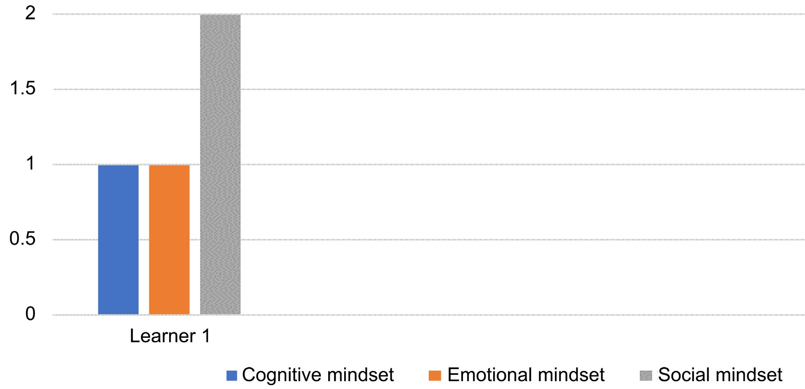
Figure 1. Thapelo profiling of mindsets within Illeris’ dimensions of learning.

percentages of each dimension concerning the growth mindset and fixed mindset.
On the cognitive level, Table 2 indicates that Thapelo’s responses were predominantly cognitive fixed mindset constituting 69% of all incidents with the most frequent (9 incidents) responses of a belief that mathematics intelligent people are born with it rather than acquiring it through learning, hard work, and perseverance. Within cognitive fixed mindset as well, Thapelo in 2 incidents perceives errors as a setback in learning. However, it can be noted also that Thapelo in 3 incidents values mathematics and sees mistakes as a resource for learning in 2 incidents. These two categories are within the cognitive growth mindset.
Within the emotional dimension, Thapelo’s responses were also predominantly emotional fixed mindset (87%), perceptions of learning with inadequacies (6 incidents), learning with uncertainty (4 incidents), and some laissez-faire attitude towards learning mathematics (4 incidents). However, Thapelo also acknowledges in 2 incidents that mathematics learning requires practice and perseverance. This category is within the emotional growth mindset.
On the social dimension, Thapelo’s responses were predominantly social growth mindset (87%), believing that learning mathematics requires support (10 incidents). Within the social growth mindset as well, Thapelo in 3 incidents believes that learners’ attributes are inconsequential in learning mathematics. However, he also indicated his feelings of non-participation in class (2 incidents). This category is within the social fixed mindset.
Overall, Thapelo’s responses during the interview indicated predominance in fixed mindset within cognitive and emotional dimensions, but growth mindset within the social dimension. Figure 1 presents a pictorial representation of Thapelo’s profile of mindset.
Figure 1 shows Thapelo’s profile of mindset, with 1 representing a fixed mindset and 2 representing a growth mindset. It was indicated that Thapelo has a fixed mindset within cognitive and emotional dimensions and a growth mindset within the social dimension.
As mentioned above, a case of Learner 1 is exemplified according to Illeris’ three dimensions of learning and the Dweck’s two types of mindsets; hence, Figure 1 shows only one learner. In the next section, I provide a qualitative analysis of selected predominant excerpts within the three dimensions of learning.
1) Thapelo’s cognitive fixed mindset
As indicated in Table 2, Thapelo’s responses in the interview regarding the cognitive dimension were predominantly a fixed mindset. One of the categories demonstrated here was that Thapelo showed a strong belief that some learners are born smart in learning mathematics—that is mathematics learning is innate (inborn). This is classified within the cognitive fixed mindset. Below I provide evidence from the interview excerpts to support this point.
Interviewer: Can you tell me about your beliefs about mathematics?
Thapelo: I find mathematics very very difficult; and mathematics is not my path.
Interviewer: Please explain how.
Thapelo: I am not committed to mathematics because mathematics is not my path, not my way of life, and not in existence because of me as well.
Interviewer: Must you have to be a “special” person in order to be good at mathematics?
Thapelo: Yes, you have to be a “special” person in order to be good at mathematics.
Interviewer: Explain, please.
Thapelo: Like I said, you have to be a “mathematics person” in order to be good in mathematics because if you are knowledgeable in mathematics. I think a “mathematics person” is the same as a “special” person here.
The excerpts above infer that Thapelo strongly believes that some learners are born with the intelligence to effectively learn mathematics. That is some learners possess special knowledge and understanding of mathematics from God. In other words, being knowledgeable in mathematics and its learning is inborn (innate). These beliefs are associated with a learner who holds a fixed mindset and may have consequences on the learning of the subject. Literature suggests that this constrains success in learning the subjects as some learners believe that intelligence and smartness are innate and cannot be learned, that is, nothing anyone can do to change these central personalities (Haimovitz & Dweck, 2017; Zhang, Kuusisto, & Tirri, 2017; Boaler, 2013; Dweck, 2013b; Dweck, 2006). This is evident in how a learner engages with his/her learning. Mindsets have a vital role in learning as a learner’s mindset affects his/her learning. One may argue that Thapelo’s low achievement in mathematics may have a link with his mindset.
2) Thapelo’s emotional fixed mindset
As indicated in Table 2, Thapelo’s responses in the interview regarding the emotional dimension were predominantly a fixed mindset. One of the categories demonstrated here was Thapelo’s attitude regarding his competence in learning mathematics. This is classified within the emotional fixed mindset. Below I provide evidence from the interview excerpts to support this point.
Interviewer: Do you feel competent to do mathematics?
Thapelo: No ooo, I do not feel competent to do mathematics.
Interviewer: Do you pass mathematics examinations easily?
Thapelo: No, I do not pass mathematics examinations easily. I guess I am not competent enough.
Interviewer: Do you think that you are good at mathematics?
Thapelo: No ooo, I am good at mathematics.
Interviewer: Why?
Thapelo: I am not good at mathematics given that I failed my grade last year because of mathematics since I am not competent [smiles].
The above excerpts by Thapelo infer that he perceived himself as not competent in learning mathematics well. That is, Thapelo lacks the self-competence to do mathematics effectively. What is interesting is the fact that Thapelo was so open to expressing his lack of competence to learn mathematics. This is an indication of a learner who holds a fixed mindset, and it constrains effective learning of the subject. Literature suggests that every learner must be competent to study mathematics; invariably, a learner who is not competent in learning mathematics will not be able to learn it (mathematics) effectively. This has been shown to have a negative influence on learning mathematics (Bansilal, Webb, & James, 2015; Darragh, 2013). Again, one may argue that Thapelo’s perception of himself as incompetent to learn mathematics may influence his achievement in the subject.
3) Thapelo’s social growth mindset
As indicated in Table 2, Thapelo’s responses in the interview regarding the social dimension were growth mindset. One of the categories demonstrated here was Thapelo’s views on the social support that he gets whenever he needs or seeks support from his teacher, family members, and peers. This is classified within the social growth mindset. Below I provide evidence from the interview excerpts to support this point.
Interviewer: How would you describe your relationship with the mathemat-
ics teacher?
Thapelo: My mathematics teacher is very helpful, happy, and friendly. If
you told him (teacher) something, he does not shout at you, he is always ready to teach you at any time.
Interviewer: Do your peers (classmates/other learners) help you in any way when you need assistance in mathematics learning?
Thapelo: Some of my classmates help me when I need their assistance in mathematics learning.
Interviewer: Explain how.
Thapelo: Some of my classmates are really clever, so they understand the work. When I ask them for help, they do help me.
Interviewer: Do your peers (classmates/other learners) assist you in doing your mathematics assignments (classwork)?
Thapelo: Yes, my peers assist me in mathematics if we are working in a group, we do assist each other. That is the essence of group work.
Interviewer: Do any of your family members (siblings, parents, or guidance) contribute to your mathematics learning?
Thapelo: Yes, my family members contribute to my mathematics learning.
Interviewer: Explain how, please.
Thapelo: My family members contribute to my mathematics learning by always teaching and pushing me to study, do better, and pass at the end of the year to help me to go to the next grade.
Interviewer: Do any of your family members (siblings, parents, or guidance) assist you in doing your mathematics assignments (homework)?
Thapelo: Yes, my family members assist me with my mathematics homework.
Interviewer: How has what they (other learners, teacher, or family members) said made you think about mathematics?
Thapelo: Well, the way my brother and teacher say about mathematics is pushing me to do my work and think good about mathematics at the end of the day [smiles].
Excerpts from the interview with Thapelo indicate that he values and seeks support from different individuals to learn mathematics. This comes from his parents (family members), as well as his peers and mathematics teachers at school. These are associated with a growth mindset because there is potential to afford learning. When learners appreciate support there is potential for some learning to occur (Martin, 2006; Nasir & Hand, 2006; Reyes & Stanic, 1998).
It is worth noting that Thapelo’s profile indicated a fixed mindset at both cognitive and emotional dimensions, but interestingly growth mindset at the social dimension, and more specifically at the level of “support” to learn. Schratz (2006) proposes four states of awareness that individuals undergo when new innovations are introduced into the school system to document changes in practise. One of this state of awareness he termed “conscious incompetence”—a situation where an individual recognizes limitations of his/her knowledge, which set that individual at the level of insecurity. Abdulhamid and Venkat (2018) found that individuals in this state lookout for support to fill in the knowledge gap. It is evident that Thapelo acknowledges his level of incompetence in the learning of mathematics. One may argue that it is this acknowledgement that makes Thapelo develop a growth mindset at the level of the social dimension.
Figure 2 below presents a summary of the profiling of the mindset of the five low achiever learners within the Illeris’ three dimensions of learning.
Figure 2 shows a similar pattern of mindset with learners 1, 4 and 5 having fixed mindset within cognitive and emotional dimensions and growth mindset within the social dimension. Learner 3 is a classical case having a fixed mindset within all three dimensions of learning. A typical case of a low achiever in mathematics. An interesting outcome was the case of learner 2 with a growth mindset within the three dimensions of learning, however, she was categorized as a low achiever in mathematics. This is a case that may need further interrogation, which is beyond the scope of this paper.

High Achievers’ Learners
The five learners who are in the category of high achievers are Learners 6 - 10. I, therefore, examined a case study of one learner, a typical of the broader data set in detail by exploring the influences of her inferred mindsets on the learning of mathematics. A case of Sipho (Learner 6) is exemplified below according to Illeris’ three dimensions of learning and the Dweck’s two types of mindsets.

A Case of Sipho
Sipho is a Black male who is a high achiever in mathematics. Table 3 and Figure 3 present summaries of the findings of the interview with Sipho. Table 3 presents a summary of Sipho’s case by itemizing the categories with their corresponding frequencies within their dimensions respectively, as well as the percentages of each dimension concerning the growth mindset and fixed mindset.
On the cognitive level, Table 3 indicated that Sipho’s responses were completely cognitive growth mindset (100%) of all incidents with the most frequent

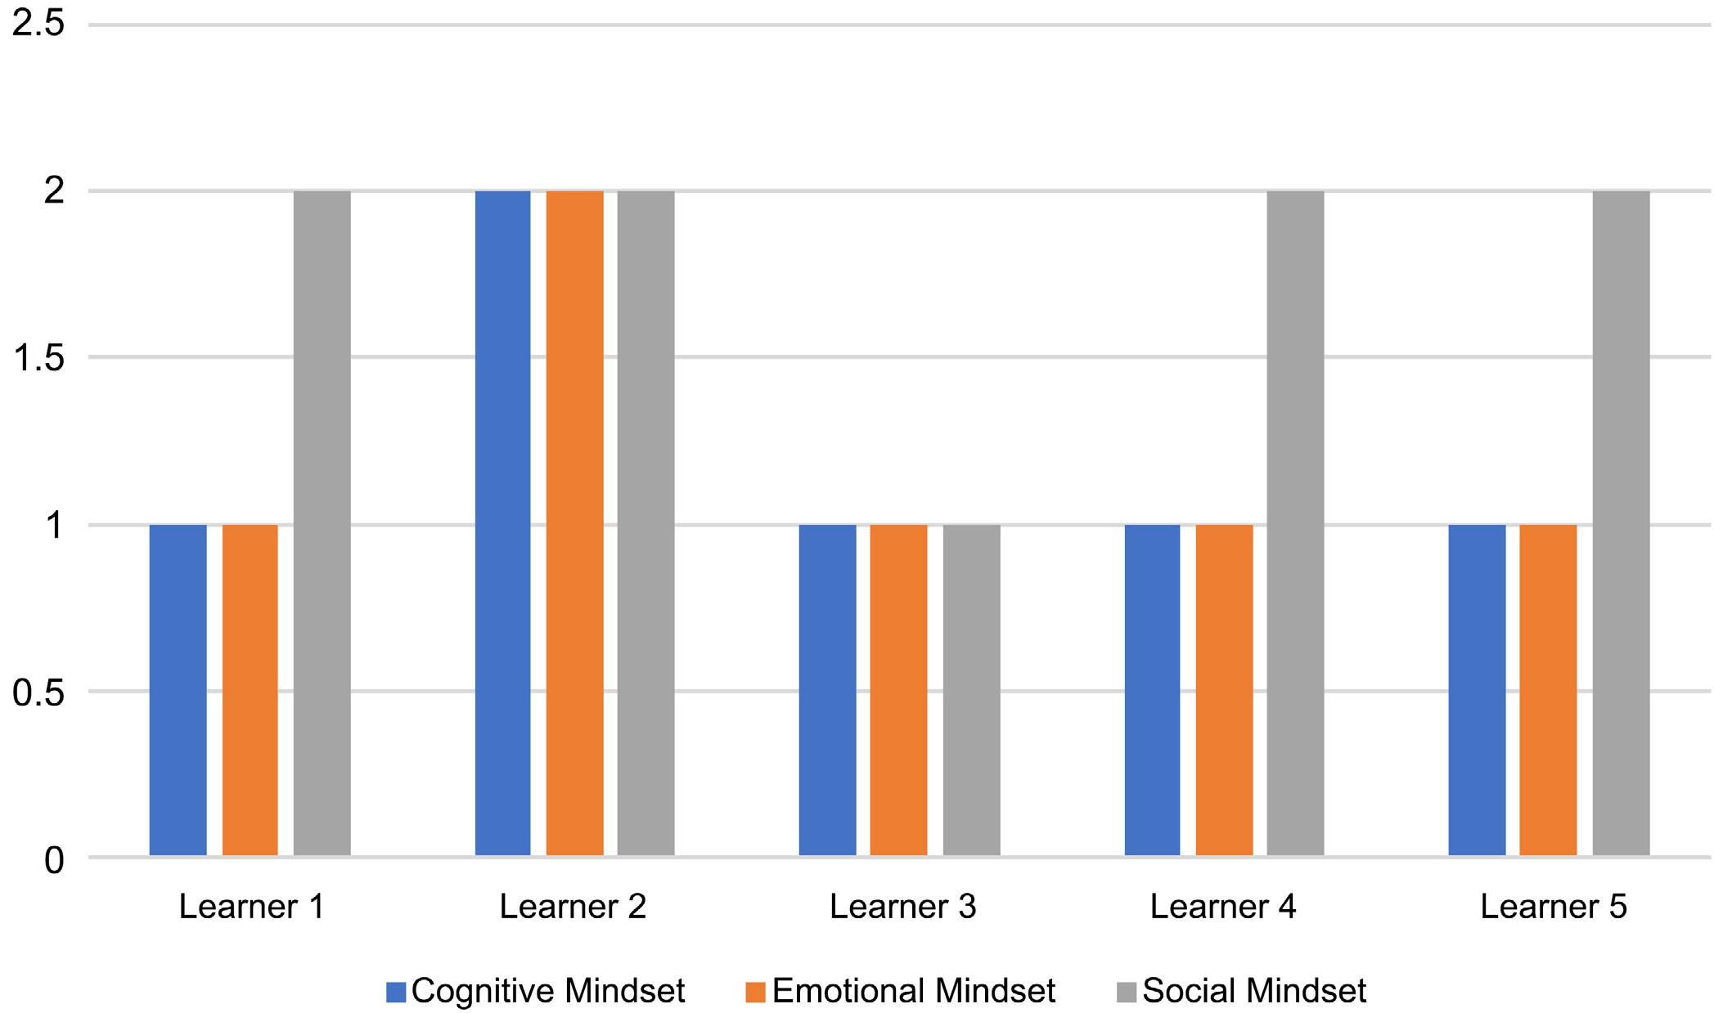
Figure 2. Five low achievers learners profiling of mindsets within Illeri’s dimensions of learning.
Table 3. Summary of Sipho categorization of mindsets within Illeris’ dimensions of learning.
Dimension  Growth Mindset  of Learning |  |  | Fixed Mindset
Cognitive dimension | Learning not innate (4)  Errors as a resource in learning (2)  Learning mathematics as valuable  (4) | 10/10 (100% of all categories in the cognitive dimension are growth mindset) | Born smart in learning (0)  Errors as a setback in learning (0)  Learning mathematics is not useful (0) | 0/10 (0% of all categories in the cognitive dimension are fixed mindset)
Emotional dimension | Excited when learning (4)  Learning through practice and perseverance (4)  Learning with confidence (3) | 12/15 (90% of all categories in the emotional dimension are growth mindset) | Bored when learning (2)  Laissez-faire attitude towards learning (1)  Learning with uncertainty (0) | 3/15 (10% of all categories in the emotional dimension are fixed mindset)
 | Feeling competent to learn (1) |  | Learning with inadequateness (0)
Social dimension | Learners’ attribute  inconsequentiality in learning (3)  Learning through participation (0)  Learning through support (7) | 10/10 (100% of all categories in the social dimension are growth mindset) | Learners’ attribute influences 0/10 (0% of all  learning (0) categories in the  social dimension  Non-participation in class (0) are fixed mindset)

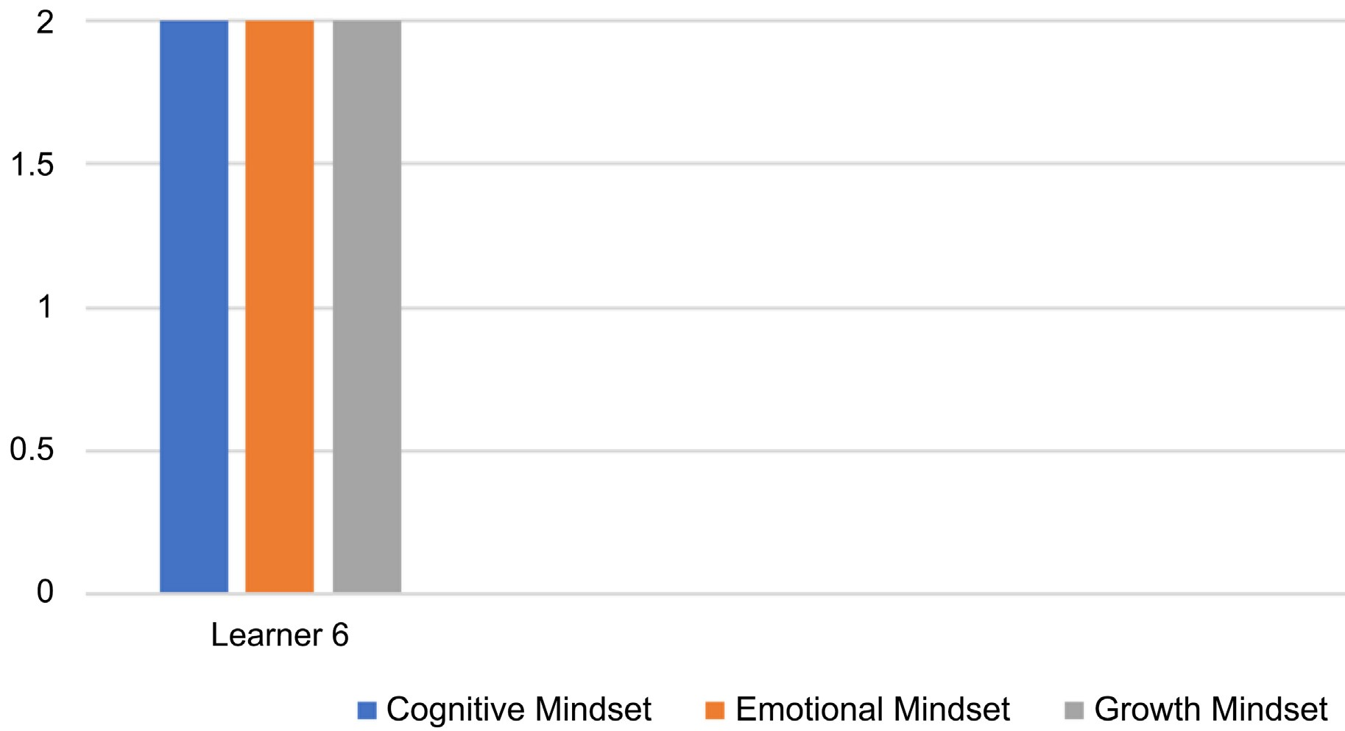
Figure 3. Sipho profiling of mindsets within Illeris’ dimensions of learning.

responses in 4 incidents believing that learning mathematics is not inborn (innate). More so Sipho mentioned some views about the values of mathematics (4 incidents), as well as perceives mistakes as a resource for learning (2 incidents).
Within the emotional dimension, Sipho’s responses were predominantly emotional growth mindset (90%) of all incidents with the most frequent responses believing in learning through practice and perseverance (4 incidents), as well as feeling excited when learning (4 incidents). Furthermore, Sipho’s responses indicate learning with confidence (3 incidents) and learning with competence (1 incident). On the contrary, Sipho also acknowledges in 2 incidents her attitudes of being bored when learning mathematics and in 1 incident her laissez-faire attitude towards learning mathematics. These categories are within the emotional fixed mindset.
On the social dimension, Sipho’s responses were completely social growth mindset (100%), believing that learning mathematics requires support (7 incidents), as well as learners’ attributes are inconsequential in learning mathematics (3 incidents).
Overall, Sipho’s responses during the interview indicated a complete growth mindset within cognitive and social dimensions, and a predominance in growth mindset within the emotional dimension. In the next section, I provide a qualitative analysis of selected predominant extracts within the three dimensions of learning.
Figure 3 shows Sipho’s profile of mindset, with 1 representing a fixed mindset and 2 representing a growth mindset. It was indicated that Sipho has growth mindsets within all three dimensions of learning.
As mentioned above, a case of Learner 6 is exemplified according to Illeris’ three dimensions of learning and the Dweck’s two types of mindsets; hence, Figure 3 shows just one learner. In the next section, I provide a qualitative analysis of selected predominant excerpts within the three dimensions of learning.
1) Sipho’s cognitive growth mindset
As indicated in Table 3, Sipho’s responses in the interview regarding the cognitive dimension were completely a fixed mindset. One of the categories demonstrated here was that Sipho has a strong belief that learners are not born smart in learning mathematics—that is mathematics learning is not innate (inborn). This is classified within the cognitive growth mindset. Below I provide evidence from the interview extracts to support this point.
Interviewer: Must you have to be a “special” person in order to be good at mathematics?
Sipho: No ooo, I do not think so.
Interviewer: Explain, please.
Sipho: I do not think that one has to be a “special” person in order to be good in mathematics. This is so because you just have to read and practice mathematics to be good at it.
Interviewer: Is there anything else you would like to say about mathematics learning? Is there any other challenge you may want to say?
Sipho: Emmm one must not be gifted to do or study mathematics properly. I think you will be capable of doing mathematics if you are focused on doing it [smiles].
The extracts from the interview with Sipho reveal that learners are not talented or born to effectively learn mathematics. Simply put, no one is born smart in learning mathematics as being smart or good at mathematics can be learned. These beliefs are related to a learner who has constructed a growth mindset and they afford learning of the subject. Literature suggests that this affords success in learning as the learners believe that intelligence and smartness are not inborn but can be learned (Bernecker & Job, 2019; Dweck, 2006, 2007; Haimovitz & Dweck, 2017).
2) Sipho’s emotional growth mindset
As indicated in Table 3, Sipho’s responses in the interview relating to the emotional dimension were predominantly growth mindset. One of the categories demonstrated here was that Sipho feels excited when learning mathematics. This is classified within the emotional growth mindset. Below I provide evidence from the interview extracts to support this point.
Interviewer: Do you feel happy whenever it’s time for mathematics class?
Sipho: Yes, I do feel happy whenever it is time for mathematics class. I rejoice at doing mathematics.
Interviewer: How will you describe yourself in the learning of mathematics?
Sipho: I am always happy when I am learning mathematics.
Interviewer: Why?
Sipho: I am always happy and feel excited when I am learning mathematics because I really enjoy doing mathematics.
In light of the above extracts from the interview with Sipho, there are indications that he finds mathematics and its learning exciting and enjoyable; hence, he feels so interested in learning mathematics, as well as happy when learning the subject. These attitudes are a pointer to a learner who holds a growth mindset, and they enhance learning of the subject. Literature suggests that learners who have constructed a growth mindset in learning mathematics revealed a substantial increase in their interest, valuing, and enjoyment of the subject (Boaler, 2013; Uwerhiavwe, 2014).
3) Sipho’s social growth mindset
As indicated in Table 3, Sipho’s responses in the interview regarding the social dimension were completely growth mindset. One of the categories demonstrated here was Sipho’s perceptions on the social support that he gets whenever he needs or seeks support from his mathematics teacher, family members, and peers. This is classified within the social growth mindset. Below I provide evidence from the interview extracts to support this point.
Interviewer: When you are stuck on a mathematics problem or when you get
something wrong, what do you do or say?
Sipho: When I am stuck on a mathematics problem, I ask the mathe-
matics teacher. However, if the mathematics teacher is not available for me to ask him, I keep on practising the problem until I get it right or see the mathematics teacher.
Interviewer: What about other learners?
Sipho: When I am stuck on a mathematics problem, the other learners help me to figure it out if they can [smiles].
Interviewer: What about your teacher?
Sipho: When I am stuck on a mathematics problem, my teacher helps
me out when she is told about it or available.
Interviewer: What about your family members?
Sipho: When I am stuck on a mathematics problem, my uncle helps me.
The extracts from the interview with Sipho point out that he gets the amount of support he needs in mathematics and its learning at home from their parents (family members), as well as the support he needs from their peers and mathematics teachers at school. These are associated with a learner who has developed a growth mindset and who afford learning of the subject. When learners are having the necessary support needed for effective learning from their mathematics teachers, family members, and peers, it affords the learners in the learning process (Martin, 2006; Nasir & Hand, 2006; Reyes & Stanic, 1998).
Figure 4 below presents a summary of the profiling of the mindset of the five high achiever learners within the Illeris’ three dimensions of learning.
Figure 4 shows a similar pattern of mindset with learners 6, 7, 8 and 9, presenting a classic case of high achievers with growth mindsets within all three dimensions of learning. Learner 10 demonstrates a fixed mindset within the emotional dimension of learning.

Discussion of Findings
In light of the analysis of findings based on the ten learners, I have noted a pattern of mindsets in relation to learners’ achievement in mathematics. As indicated in Figure 5, I noted a more classical case of high achievers being associated with a growth mindset as indicated in the case of learners 6 to 9. It is somehow a complex pattern is noted in the case of low achievers, only one learner (Learner
3) shows a classic case of a low achiever with a fixed mindset across all three

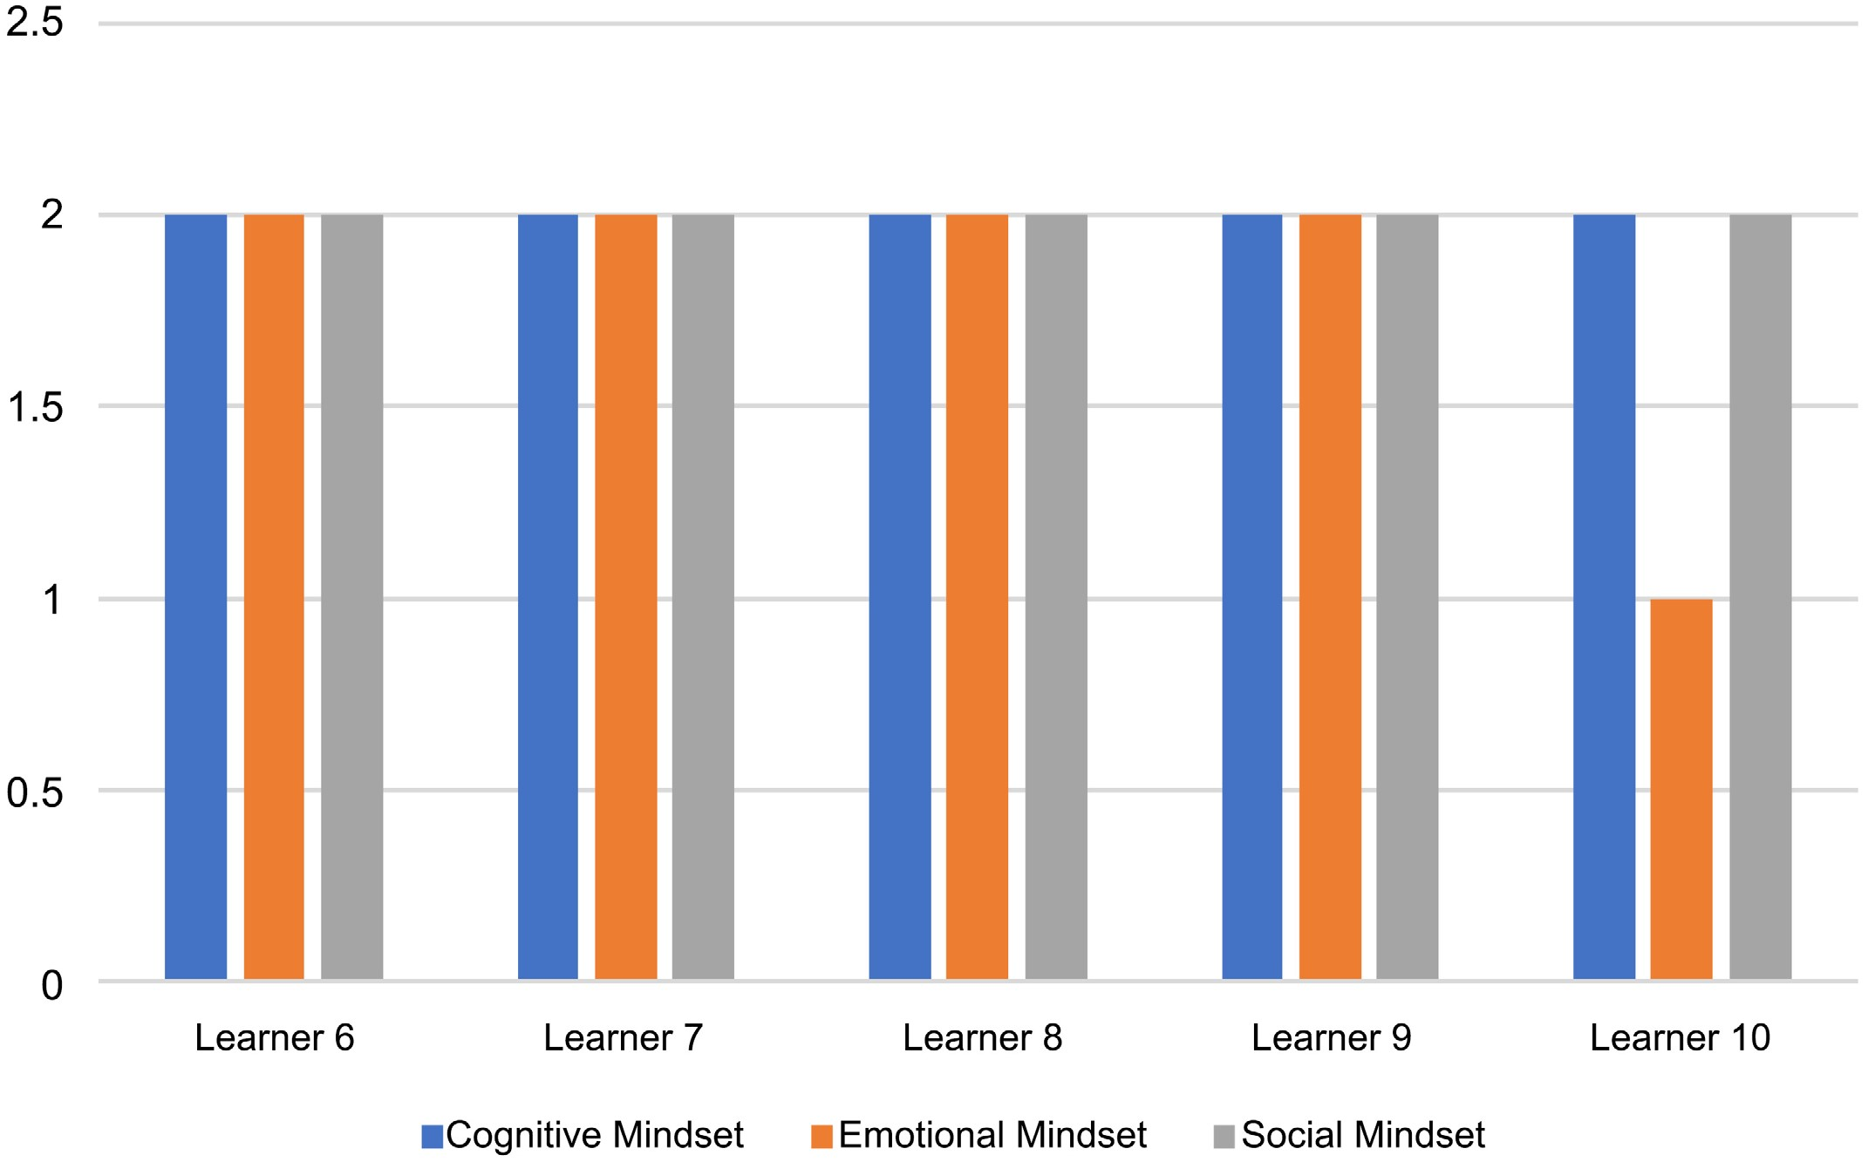
Figure 4. Five high achievers learners profiling of mindsets within Illeris’ dimensions of learning.
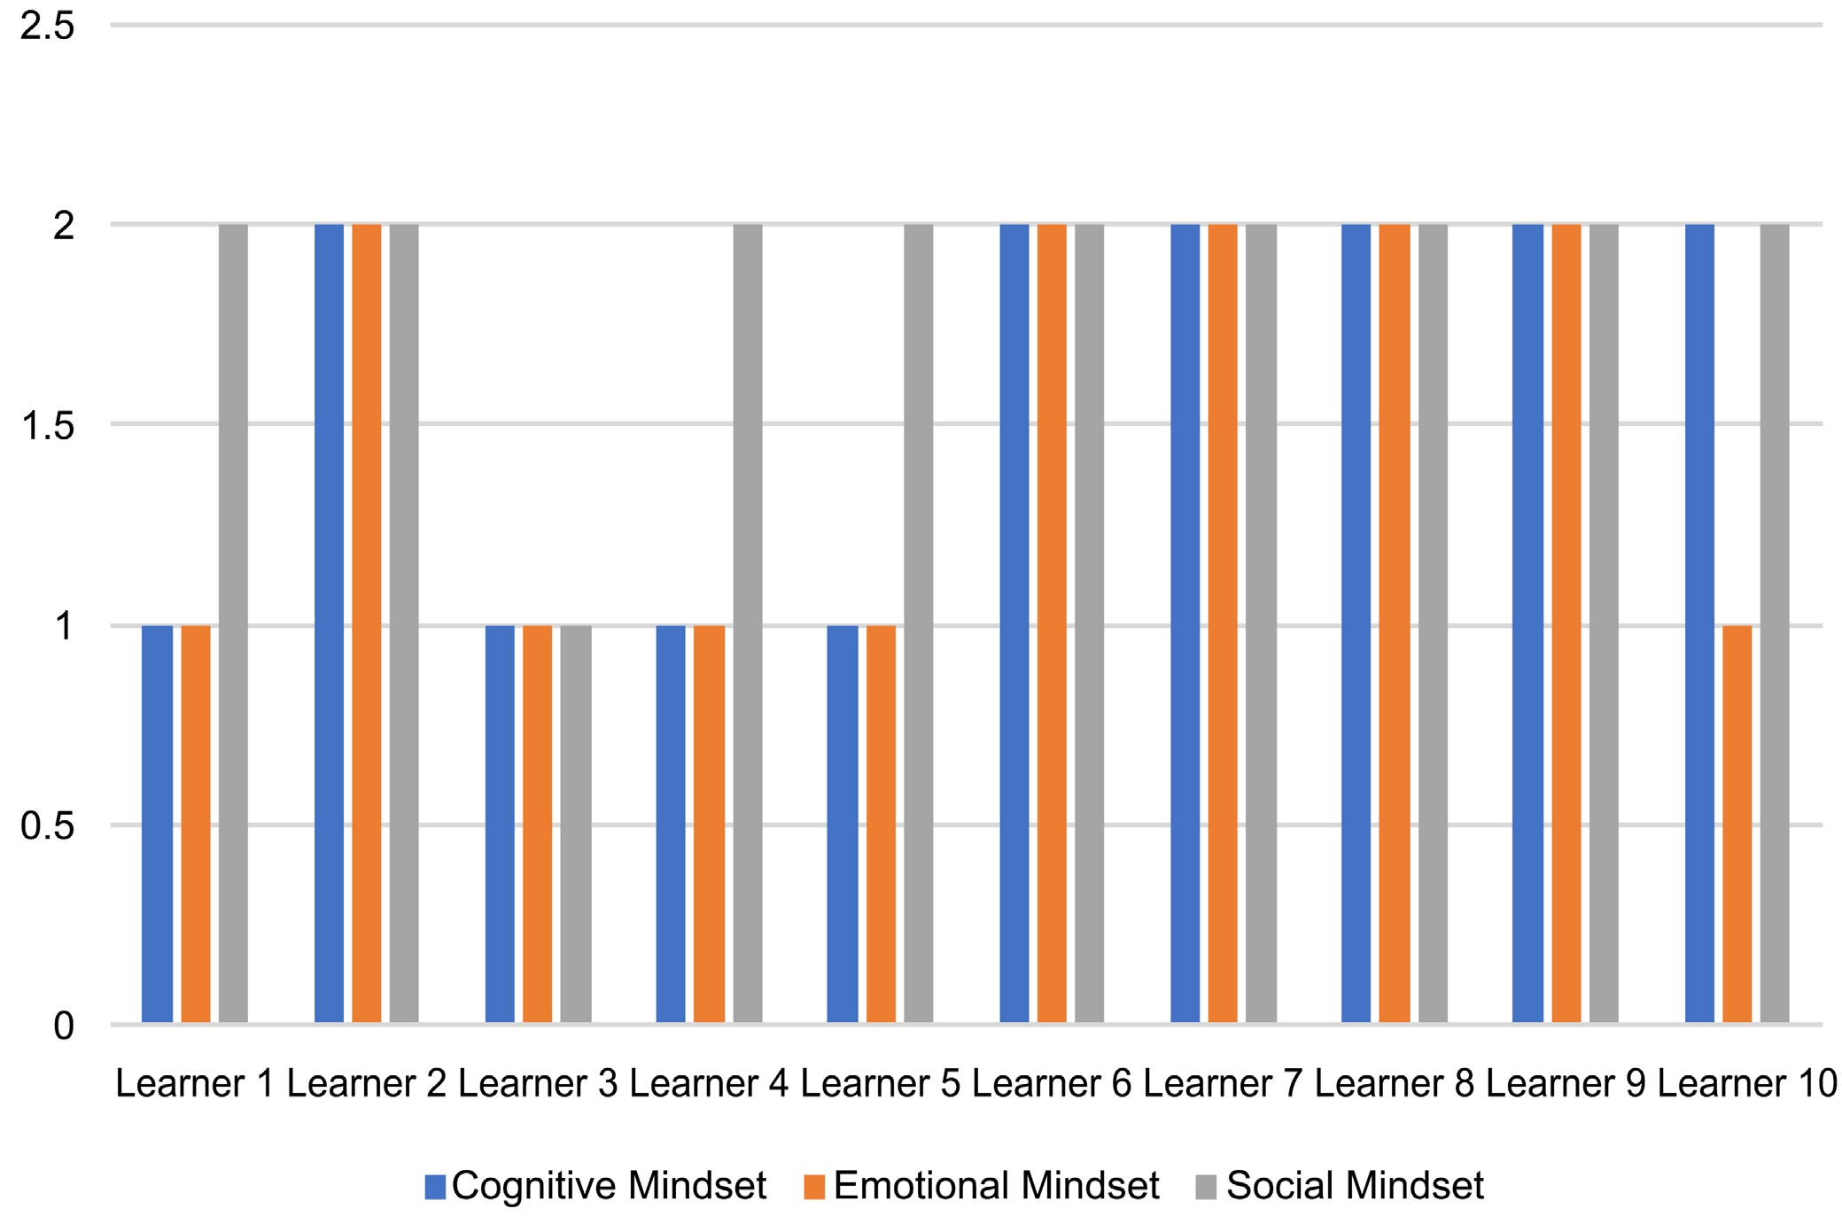
Figure 5. Five high achievers learners profiling of mindsets within Illeri’s dimensions of learning.

dimensions. An interesting emergent pattern was the case of the three learners that demonstrated a growth mindset within the social dimension of learning.
In light of the analysis of findings based on the ten learners, for the learners who are high achievers, the chart indicates that Sipho, Karl, Lerato and Cindy are exactly the same; all of them are growth mindset in the cognitive, emotional and social dimensions. In other words, none of them has got a fixed mindset in terms of the cognitive, emotional and social dimensions; that is, they are not in anyways lacking cognitively, emotionally, or socially. This indicates that learners who are high achieving do have a better sense of themselves, cognitively; they also feel more emotionally confident, and they also utilize the social support that may be needed. The only case that is not as typical as that is Busisiwe, who is low in terms of emotional dimension—i.e., she is fixed within the emotional dimension. This learner does not feel emotionally confident, although, she is a high achiever. More so, Busisiwe is growth and fixed in terms of the cognitive dimension.
For the learners who are low achievers, the chart indicates that Lebogang and Charles are exactly the same as Sipho, Karl, Lerato and Cindy; that is, Lebogang and Charles are the cases that are completely different among the low achievers; the two learners are growth mindset in the cognitive, emotional and social dimensions, yet they are low achievers in the learning process of an SFSCS.
Furthermore, the chart indicates that Thapelo and Mpho are similar as they are lacking within the cognitive and emotional dimensions except for the social dimension; this is a case of when learners feel that they are lacking cognitively and emotionally, they turn to social for more support. Interestingly, Lisa is a unique and classic case among the low achievers, as well as across all the ten learners because she is a fixed mindset in terms of the cognitive, emotional and social dimensions in the learning process of an SFSCS.
In light of the analysis of findings based on the ten learners and ensuing from the chart in Figure 5, the three dimensions (cognitive, emotional and social) are central as they connect each other; however, the learners view the social dimension as the most important in the learning process of an SFSCS. More so, the learners who are high achievers are balanced and none of them views the cognitive dimension in fixed ways; and the learners who are low achievers lack on cognitive and emotional levels (dimensions) more and view the social level, therefore, as important. Furthermore, the cognitive, emotional and social dimensions seem to be responsible for influencing the learners’ learning leading to achievements or performances in the learning process. There is an influence of mindset on their achievement which is located in the cognitive, emotional and social dimensions of the learning process.
Generally, drawing on the analysis of findings given the ten learners, the cognitive, emotional and social dimensions seem to be responsible for influencing the learners’ learning leading to their achievements in the subject. It is crucial to note at this point that achievement does not infer that all the dimensions must be positive at all times in the learning process. Some dimensions may seem to constrain learning, yet a learner still performs well, and some dimensions may seem to afford learning, yet a learner still performs poorly. As such, there is an influence of mindset on the learners’ achievement which is located in the cognitive, emotional and social dimensions of the learning process.

Conclusion
In this paper, I found that learners’ mindset has various consequences on their learning, such as the growth mindset has influences on learning as it affords learning and leads to success in learning, and the fixed mindset equally has influences on learning as it tends to constrain learning and fundamentally leads to failure in learning (Dweck, 2006, 2007; Tirri & Kujala, 2016). In this sense, interventions that teach learners with a fixed mindset can improve the learners’ achievement with time suggesting the fundamental role of these mindsets in enhancing the learners’ motivation plus their achievement” in learning. More so, interventions represent a powerful means of transmitting a growth mindset to learners who have constructed a fixed mindset. Interventions teach a fixed mindset by transmitting the ways learners’ intelligence and abilities can grow stronger over time by taking on hard tasks and persisting in learning (Haimovitz & Dweck, 2017). An intervention can shape learners with a fixed mindset perception of their abilities and influence their motivation and achievements in learning.
I also found that high achievement is possible if the cognitive and the social are dealt with concurrently and positively. As such, if you view learners on the cognitive level with a growth mindset, and emotionally with a growth mindset, as well as socially with a growth mindset and they all work concurrently—which is what high achievers’ profiles show, then high achievement can be achieved. In other words, we need to work with the cognitive, emotional and social all together all the time and keep in mind that in each dimension there are many variables. So, the cognitive is made up of a lot of things, the emotional is made up of a lot of things, and the social is made up of a lot of things, and that is complex. If we can get those interplays within the different dimensions to work concurrently in a balanced way, then high achievement can be achieved.
Mindsets are socially constructed, but they interplay between the cognitive, emotional and social, and they emerge out of all of those. Simply put, mindsets are never only social, and that is why they emerge out of the cognitive, emotional and social levels, hence, mindsets are socially constructed. That is because mindsets are fluid and dynamic as well, as well as change all the time, and that means, as well as the reason why people do not fit neatly into a growth mindset or fixed mindset.
Social learning theories and mindsets theories should be viewed together to avoid mindsets being viewed as and leading to innatist assumptions about learning possibilities. That is, if we work with social learning theories, as well as see mindsets theories in relation to social learning theories and they are viewed together, then one of the effects that it can have is to prevent people from seeing mindsets as innate. In other words, if you work with social learning theories and mindsets theories together, it will help to move away from innatist assumptions. More so, if you work with social learning theories together with mindsets theories, then you will see that learning is complex and dynamic, it is about an interplay between internal and external forces, and they operate on all three dimensions and all of these things are dynamic, as well as affect the constructing of mindsets.
In line with the above, I conclude with the following answers: 1) to the first research question, mindsets play a crucial role by influencing the cognitive, emotional and social dimensions of learning, which in turn, have an impact on the learners’ achievements in an SFSCS like mathematics in the learning process and 2) regarding the second question, the social dimension has more influence on learning as it is extremely substantial in influencing learners’ achievements in the learning process.
The following research topics are proposed for future exploration based on this paper:
- Learners’ Mathematical Personal Identities and Mathematics Learning.
- Learners’ Mathematical Identities in Urban Secondary School.
- Learners’ Mathematical Identities: Does Mindsets Matter?
- Is Mindset an Appetite for Mathematics Learning?
- Mindsets: Drivers for Learning.
- Mathematics Learning: Does Mindset Matter?

Acknowledgements
I am particularly grateful to the principal and vice-principal who permitted me to use their school for the data collection. I am also grateful to the mathematics teachers, the ten mathematics learners, and their parents who consented to be part of this research paper and treated the exercise as very important. My very warm appreciation goes to Dr. Lawan Abdulhamid for his assistance. I hereby acknowledge myself as well as this paper is a function of my doctoral thesis.

Conflicts of Interest
The author declares no conflicts of interest regarding the publication of this paper.

References
Abdulhamid, L., & Venkat, H. (2018). Primary Mathematics Teachers’ Responses to Students’ Offers: An “Elaboration” Framework. Journal of Mathematical Behavior, 51,
80-94. https://doi.org/10.1016/j.jmathb.2017.08.007
Adolphus, T. (2011). Problems of Teaching and Learning of Geometry in Secondary Schools in Rivers State, Nigeria. International Journal of Emerging Sciences, 1, 143-152.
Ali, I., Bhagawati, S., & Sarmah, J. (2014). Performance of Geometry among the Secondary School Students of Bhurbandha CD Block of Morigaon District, Assam, India. In-
ternational Journal of Innovative Research and Development, 3, 73-77.
Anthony, G., & Walshaw, M. (2009). Effective Pedagogy in Mathematics. UNESCO and
International Bureau of Education, Educational Practices Series 19, Gonnet Imprimeur.
Attard, C. (2011). “My Favourite Subject Is Mathematics. For Some Reason No-One Really Agrees with Me”: Student Perspectives of Mathematics Teaching and Learning in the Upper Primary Classroom. Mathematics Education Research Journal, 23, 363-377. https://doi.org/10.1007/s13394-011-0020-5
Badyal, D. K., & Singh, T. (2017). Learning Theories: The Basics to Learn in Medical Education. International Journal of Applied and Basic Medical Research, 7, S1-S3. https://doi.org/10.4103/ijabmr.IJABMR_385_17
Bansilal, S., Webb, L., & James, A. (2015). Teacher Training for Mathematical Literacy: A Case Study Taking the Past into the Future. South African Journal of Education, 35, 1-10.
Barnes, H. E. (2009). Pre-Service Teachers’ Mathematics Profiles and the Influence Thereof on Their Instructional Behavior. PhD Thesis, University of Pretoria, Pretoria.
Bernecker, K., & Job, V. (2019). Mindset Theory. In K. Sassenberg, & M. L. W. Vliek (Eds.), Social Psychology in Action (pp. 179-191). Springer. https://doi.org/10.1007/978-3-030-13788-5_12
Bernstein, B. (1973a). Class, Codes and Control (Vol. 2). Routledge & Kegan Paul.
Bernstein, B. (1973b). On the Classification and Framing of Educational Knowledge. In R.
Brown (Ed.), Knowledge, Education, and Cultural Change. Routledge.
Bernstein, B. (1975). Class, Codes and Control Volume 3: Towards a Theory of Educational Transmissions. Routledge & Kegan Paul.
Bishop, J. P. (2012). “She’s Always Been the Smart One. I’ve Always Been the Dumb
One”: Identities in the Mathematics Classroom. Journal for Research in Mathematics Education, 43, 34-74. https://doi.org/10.5951/jresematheduc.43.1.0034
Blackwell, L. S., Trzesniewski, K. H., & Dweck, C. S. (2007). Implicit Theories of Intelligence Predict Achievement across an Adolescent Transition: A Longitudinal Study and an Intervention. Child Development, 78, 246-263.
https://doi.org/10.1111/j.1467-8624.2007.00995.x
Boaler, J. (2013). Ability and Mathematics: The Mindset Revolution That Is Reshaping Education. Forum, 55, 143-152. https://doi.org/10.2304/forum.2013.55.1.143
Boaler, J. (2016). Mathematical Mindsets: Unleashing Students’ Potential through Creative Math, Inspiring Messages, and Innovative Teaching (1st ed.). PB Printing.
Boaler, J., William, D., & Zevenbergen, R. (2000). The Construction of Identity in Secondary Mathematics Education. In The International Mathematics Education and So-
ciety Conference (pp. 26-31). Montechoro.
Cann, R. (2009). Girls’ Participation in Post-16 Mathematics: A View from Pupils in Wales. Gender and Education, 21, 651-669. https://doi.org/10.1080/09540250802680065
Cohen, L., Manion, L., & Morrison, K. (2007). Research Methods in Education (6th ed.).
Routledge. https://doi.org/10.4324/9780203029053 Creswell, J. (2012). Educational Research. Pearson.
Darragh, L. (2013). Constructing Confidence and Identities of Belonging in Mathematics at the Transition to Secondary School. Research in Mathematics Education, 15, 215-229. https://doi.org/10.1080/14794802.2013.803775
Department of Basic Education (2014). National Senior Certificate Examination School Subject Report. Department of Basic Education, South Africa.
Department of Education (2002). Revised National Curriculum Statement (Grader-9). Department of Education, South Africa.
Dweck, C. S. (2000). Self-Theories: Their Role in Motivation, Personality, and Development. Taylor & Francis Group.
Dweck, C. S. (2006). Mindset: The New Psychology of Success. Random House.
Dweck, C. S. (2007). Is Math a Gift? Beliefs That Put Females at Risk. In S. J. Ceci, & W. Williams (Eds.), Why Aren’t More Women in Science? Top Researchers Debate the Evidence (pp. 47-55). American Psychological Association.
Dweck, C. S. (2012). Personal Communication, Teaching Mathematics for a Growth Mindset Workshop. Stanford University.
Dweck, C. S. (2013a). Mindset. http://en.wikipedia.org/wiki/Mindset
Dweck, C. S. (2013b). Mindset—The New Psychology of Success at Happiness and Its
Causes. https://www.youtube.com/watch?v=QGvR_0mNpWM
Dweck, C. S. (2013c). Teaching a Growth Mindset’ at Young Minds. https://www.youtube.com/watch?v=kXhbtCcmsyQ
Ertmer, P. A., & Newby, T. J. (2013). Behaviorism, Cognitivism, Constructivism: Comparing Critical Features from an Instructional Design Perspective. Performance Im-
provement Quarterly, 26, 43-71. https://doi.org/10.1002/piq.21143
Fontana, A., & Frey, J. H. (2000). The Interview: From Structured Questions to Negotiated Text. In N. K. Denzin, & Y. S. Lincoln (Eds.), The Sage Handbook of Qualitative Research (2nd ed., pp. 645-672). Sage.
Haimovitz, K., & Dweck, C. S. (2017). The Origins of Children’s Growth and Fixed Mindsets: New Research and a New Proposal. Child Development, 88, 1849-1859. https://doi.org/10.1111/cdev.12955
Heyd-Metzuyanim, E. (2013). The Co-Construction of Learning Difficulties in Mathematics-Teacher-Student Interactions and Their Role in the Development of a Disabled Mathematical Identity. Educational Studies in Mathematics, 83, 341-368. https://doi.org/10.1007/s10649-012-9457-z
Illeris, K. (2002). The Three Dimensions of Learning: Contemporary Learning Theory in the Tension Field between the Cognitive, the Emotional and the Social. NIACE.
Illeris, K. (2003). Towards a Contemporary and Comprehensive Theory of Learning. Int. Journal of Lifelong Education, 22, 396-406. https://doi.org/10.1080/02601370304837
Illeris, K. (2007). How We Learn: Learning and Non-Learning in School and Beyond. Routledge. https://doi.org/10.4324/9780203939895
Illeris, K. (2009). A Comprehensive Understanding of Human Learning. In K. Illeris (Ed.), Contemporary Theories of Learning (pp. 7-20). Routledge. https://doi.org/10.4324/9780203870426
Illeris, K. (2015). The Development of a Comprehensive and Coherent Theory of Learning. European Journal of Education, 50, 29-40. https://doi.org/10.1111/ejed.12103
Jansen, J. (1999). A Very Noisy OBE: The Implementation of OBE in Grade 1 Classrooms. In J. Jansen, & P. Christie (Eds.). Changing Curriculum: Studies on Outcomes-Based Education in South Africa (pp. 203-218). Juta.
Leder, G. C., & Taylor, P. J. (2010). Are Raelene, Marjorie, and Betty Still in the Race? Australian Mathematics Teacher, 66, 17-24.
Maliki, A. E., Ngban, A. N., & Ibu, J. E. (2009). Analysis of Students’ Performance in Junior Secondary School Mathematics Examination in Bayelsa State of Nigeria. Studies
on Home and Community Science, 3, 131-134.
https://doi.org/10.1080/09737189.2009.11885288
Martin, D. B. (2006). Mathematics Learning and Participation as Racialized Forms of Experience: African American Parents Speak on the Struggle for Mathematics Literacy.
Mathematical Thinking and Learning, 8, 197-229. https://doi.org/10.1207/s15327833mtl0803_2
Mbugua, Z. K., Kibet, K., Muthaa, G. M., & Nkonke, G. R. (2012). Factors Contributing to Students’ Poor Performance in Mathematics at Kenya Certificate of Secondary Education in Kenya: A Case of Baringo County, Kenya. American International Journal of Contemporary Research, 2, 87-91.
McMillan, J. H., & Schumacher, S. (2010). Research in Education: Evidence-Based Inquiry. Pearson Education.
Mercer, S., & Ryan, S. (2010). A Mindset for EFL: Learners’ Beliefs about the Role of Natural Talent. ELT Journal, 64, 436-444. https://doi.org/10.1093/elt/ccp083
Moore, M. (2018). Mindset and Mathematics in an All-Girls Secondary School. PhD Thesis, Charles Sturt University.
Murray, S. (2011). Secondary Students’ Descriptions of “Good” Mathematics Teachers. Australian Mathematics Teacher, 67, 14-20.
Nasir, N. S., & Hand, V. M. (2006). Exploring Socio-Cultural Perspectives on Race, Culture, and Learning. Review of Educational Research, 76, 449-475. https://doi.org/10.3102/00346543076004449
Patton, M. Q. (2002). Qualitative Research and Evaluation Methods (3rd ed.). Sage.
Reyes, L. H., & Stanic, G. M. A. (1998). Race, Sex, Socioeconomic Status, and Mathematics. Journal for Research in Mathematics Education, 19, 26-43. https://doi.org/10.5951/jresematheduc.19.1.0026
Schratz, M. (2006). Leading and Learning: Odd Couple’ or Powerful Match? Leading and Managing, 12, 40-53.
Schunk, D. H. (2012). Learning Theories—An Educational Perspective (6th ed.). Pearson.
Shively, R. L., & Ryan, C. S. (2013). Longitudinal Changes in College Math Students’ Implicit Theories of Intelligence. Social Psychology of Education, 16, 241-256. https://doi.org/10.1007/s11218-012-9208-0
Sibiya, M. R., & Mudaly, V. (2018). The Effects of the Geoboard on Learner Understanding of Geometry Theorems. International Journal of Sciences and Research, 74, 90-98. https://doi.org/10.21506/j.ponte.2018.11.8
Strauch, C. C., & Alomar, M. J. (2014). Critical Analysis of Learning Theories and Ideologies and Their Impact on Learning: “Review Article”. The Online Journal of Counsel-
ing and Education, 3, 62-77.
Suter, W. N. (2012). Introduction to Educational Research: A Critical Thinking Approach. Sage. https://doi.org/10.4135/9781483384443
Tirri, K., & Kujala, T. (2016). Students’ Mindsets for Learning and Their Neural Underpinnings. Psychology, 7, 1231-1239. https://doi.org/10.4236/psych.2016.79125
Tshabalala, T., & Ncube, A. C. (2013). Causes of Poor Performance of Ordinary Level Pupils in Mathematics in Rural Secondary Schools in Nkayi District: Learner’s Attributions. Nova Journal of Medical and Biological Sciences, 1, 4-14.
Uwerhiavwe, A. A. (2014). The Impact of Teacher Development and Student Preparation in Mathematics Education in Senior Secondary Schools in Delta State, Nigeria: A Collective Case Study. Master’s Dissertation, Memorial University of Newfoundland.
Van Aalderen-Smeets, S. I., & Walma Van Der Molen, J. H. (2018). Modeling the Relation between Students’ Implicit Beliefs about Their Abilities and Their Educational STEM Choices. International Journal of Technology and Design Education, 28, 1-27. https://doi.org/10.1007/s10798-016-9387-7
Vermeer, A. (2012). 15 Benefits of the Growth Mindset. https://alexvermeer.com/15-benefits-growth-mindset/
Weber, E. (2008). Educational Change in South Africa: Reflections on Local Realities,
Practices, and Reforms. Sense Publishers. https://doi.org/10.1163/9789087906603
Wenger, E. (1998). Communities of Practice. Learning, Meaning and Identity. Cambridge University Press. https://doi.org/10.1017/CBO9780511803932
Wenger, E. (2009). A Social Theory of Learning. In K. Illeris (Ed.). Contemporary Theories of Learning (pp. 209-218). Routledge.
Yeager, D. S., & Dweck, C. S. (2012). Mindsets That Promote Resilience: When Students
Believe That Personal Characteristics Can Be Developed. Educational Psychologist, 47,
302-314. https://doi.org/10.1080/00461520.2012.722805
Yong, D. (2017). Growth Mindset and Learning about Equity, Diversity, and Inclusion. https://profteacher.com/2017/04/24/growth-mindset-and-learning-about-diversity-and -inclusion/
Zhang, J., Kuusisto, E., & Tirri, K. (2017). How Teachers’ and Students’ Mindsets in Learning Have Been Studied: Research Findings on Mindset and Academic Achievement. Psychology, 8, 1363-1377. https://doi.org/10.4236/psych.2017.89089

